RFP - aMemoryJog

RFP - aMemoryJog 1
Note about this Document 3
Contact Information 3
Important Dates 3
Project Details 3
Technology 3
Cost Proposal 3
Bug Fixes 3
Payment Schedule 3
Out of Scope Items 4
Milestones and Iterative Development 4
Ball Park Estimate for iPad and Android Version 4
Fonts 4
Localization 4
Section 1: aMemoryJog Lite 5
Section 1.1 Login Screens 5
Section 1.1.1 Login Screen 5
Section 1.1.2 Forgot Password Screen 7
Section 1.1.3 Create New Account Screen 8
Section 1.2 Item Screens 10
Section 1.2.1 Home Screen (Item Listing) 10
Section 1.2.2 Item Detail Read-Only Screen 10
Section 1.2.3 Item Maintenance Screen 10
Section 1.3 Settings Screen 10
Section 1.4 Help Screen 10
Section 2: aMemoryJog Pro 10
Section 2.1 Login Screens 11
Section 2.1.1 Login Screen 11
Section 2.1.2 Forgot Password Screen 12
Section 2.1.3 Create New Account Screen 12
Section 2.2 Item Screens 13
Section 2.2.1 Home Screen (Item Listing) 13
Section 2.2.2 Item Detail Read-Only Screen 13
Section 2.2.3 Item Maintenance Screen 13
Section 2.3 Settings Screen 13
Section 2.4 Help Screen 13
Section 2.5 Recycle Bin Screen 13
Section 2.6 Sync Screen 13
Section 3 – Nag Alerts 13
Section 3.1 Upgrade from Lite to Pro Nag Alert 13
Section 3.2 Renew Cloud Backup Alert 13
Section 3.3 Ask for Review 13
Section 4 – Cloud Synchronization 13
Cloud Database (Web Server) 13
Cloud Database Account Creation and Authentication 14
Sync Localizations Updates from Cloud to Mobile 14
Sync Cloud and Mobile Data 14
Section 5 – Icons and Screen Shots for App Store 14
Section 6 – Flurry Analytics 14
Section 7 – Error Trapping 15

Modification History:
- [Date] - Description

Note about this Document
This is a sample RFP and does not contain all of the screens we created for aMemoryJog – it simply details the login process to give you an idea of what a specification might look like.

Contact Information
Company: [Your Company Name] Email: [Your Email Address]
Contact: [Your Name] Phone: [Your Phone]

Important Dates
NDA Signature Date: Wednesday, 19-March-2014
RFP Distribution Date: Thursday, 20-March-2014
Vendor RFP Response Date: Friday, 28-March-2014
Vendor Selection Date: Monday, 31-March-2014

Project Details
This RFP is for obtaining a fixed price bid for creating 2 iPhone applications:
- AMemoryJog Lite – a free edition of the future texting tool that will include some limitations and banner advertising.
- AMemoryJog Pro – a paid edition of the future texting tool that will include additional features and no banner ads.

Technology
The software should be written in a reusable way so that it can be more cost effectively extended to Android and iPad versions, which we will pursue assuming the iPhone editions do well in the App Store. All source code and intellectual property will be owned by [Your Company Name].

Cost Proposal
Your proposal should include all costs associated with developing, testing, iterative releases, and pre-release bug fixes. It should also include costs for development of iPhone icons and App Store screen shots developed in Illustrator, designed to work with iPhone 4 and iPhone 5. Please include a little time (an hour or so) for training to help a [Your Company Name] representative with uploading the app to the Apple App Store. If we need to purchase any additional software, please state that.

Bug Fixes
In your proposal, please state if we receive bug fixes for a specific warranty period and how much bug fixes will cost once the warranty expires. Also, please specify what tools your team would like to use to communicate bug fixes. If you don’t have a product to use, your company can use our copy of Zendesk to track the bugs associated with this project (we will add a user account for you).

Payment Schedule
Please provide information on how you should be paid. We prefer a staged payment process, where we pay a portion of the total cost at the delivery of each iteration via Pay Pal.

Out of Scope Items
We have taken great care to document as much as possible for this app, with wireframes and a detailed spec – all aimed at clarifying the requirements and keeping our costs down. We will work diligently to keep all development within the original scope of this document but if we do find out-of-scope items, we would like to understand the hourly cost of these types of work items.

Milestones and Iterative Development
Your proposal should include a schedule of events with milestones and delivery dates. We prefer to develop this in iterations; here is a suggested set of iterations:
- Iteration 1 (AMemoryJog Lite) – Prototype of AMemoryJog Lite application with all screens presented (navigable but not actually saving data).
- Iteration 2 (AMemoryJog Lite) – All screens fully working for the LITE edition.
- Iteration 3 (AMemoryJog Pro) –– All screens fully working for the PRO edition.
- Iteration 4 (AMemoryJog Pro) – Cloud Backup fully working, icons and screen shots completed for App Store.
At the end of each iteration, we should receive the source control and a downloadable version of the app that we can install on our iPhone. The software should work with both iPhone 4 and 5 versions.

Ball Park Estimate for iPad and Android Version
We plan to also create an iPad and Android version, assuming the iPhone version does well in the App Store. We should know how well it will do once it has been in production for a month or two. It would be good to get a ball park estimate of how much it would cost to create an iPad and Android version, just so we have a general idea of those costs.

Fonts
Helvetica is used on most iPhone devices without a Retina display. Helvetica Neue is used on devices with a Retina display, so we will use Helvetica for the fonts since we are supporting both 3.5 and 4.0 screens.

Localization
Throughout this RFP specification, you will notice that all screen fields, alerts, messages, labels, etc. should be supported in languages other than English. We will provide a spreadsheet (called Localizations) used to display information on the screen in the language the user desires (we support English, Spanish, French, German, Italian, Russian, Japanese, and Chinese).
The free version (AMemoryJog Lite) will only display information in English, so it will always use the Localizations.English field to pull back the localized data.
The paid version (AMemoryJog Pro) allows them to set the language to something other than English, so when Localizations is used, it pulls from the correct field (Localizations.English, Localizations.French, etc).
We will need a mechanism for updating this information in the future so please build a web page for allowing us to update it. Any changes there will then be updated in the mobile app once they log into the mobile app.
To see what this table looks like, here is an Excel spreadsheet with the data:
http://www.AMemoryJog.com/Localizations20140317.xlsx

Section 1: aMemoryJog Lite
aMemoryJog Lite will be the free edition of the future text tool that will include some limitations and banner advertising. It will be comprised of these screens:
- Login Screens – Login screen, forgot password screen, create new account screen
- Item Screens – Item Listing, Item Read Only screen, Item Maintenance screens.
- Help Screen – Help screen
In addition, we will have a few Nag alerts and banners to promote the paid version of the product.

Section 1.1 Login Screens
When a user downloads and opens up the app, the first screen they encounter is the Login screen.

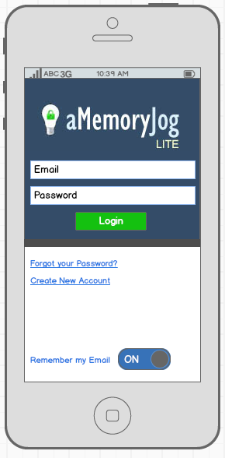
Section 1.1.1 Login Screen
Colors:
Background Top Portion Color: Dark Blue (#344c68)
Background Middle Gray Band: #4d4d4d
Background Bottom Portion: White
Text Boxes: White with blue (#5e7d9a) border, text black
Login Button: Green ( #14c110), White text
Link Colors (Forgot Your Password, Create New Account): blue (#2b78e4) and underlined.
Logo:
AMemoryJog Logo, we will provide a .GIF file. Background color is dark blue (#344c68).
Email:
Placeholder Text: Email (pull from Localizations.English field by querying based on ItemType=‘frmLogin’, ItemName=‘lblEmail’)
If the user never logged in before, it will display the placeholder text (Email and Password as shown in the screen shot). If the user has logged in before, it will display the email they last logged in with if the “Remember my Email” toggle is set. Otherwise, Email will just show the placeholder text.
Password:
Placeholder Text: Password (pull from Localizations.English field by querying based on ItemType=‘frmLogin’, ItemName=‘lblPassword’)
The text typed in will be masked so it does not show clear text, standard for password fields.
Login Button:
Text: Login (pull from Localizations.English field by querying based on ItemType=‘frmLogin’, ItemName=‘btnLogin’)
When login button touched, it will determine if the Email was entered. If not, it will display this error message from Localizations.English field by querying on ItemType=‘Messages’, ItemName=’MISSING_EMAIL’.
When login button tapped, it will determine if the Password was entered. If not, it will display this error message from the Localizations.English field by querying on ItemType=‘Messages’, ItemName=‘MISSING_PASSWORD’.
If Email and Password was entered, it will determine if the Email Address matches (not case sensitive) an entry in the database. If not, it will display an error message from the Localizations.English field by querying on ItemType=‘Messages’, ItemName=‘INVALID_EMAIL’. One of the words in the Localizations.English field will be [PRODUCTNAME], replace that with aMemoryJog.
If Email matches, it will determine if the Email Address (non-case sensitive) and Password (case sensitive) match an entry in the database. If not, it will display an error message from the Localizations.English field by querying on ItemType=‘Messages’, ItemName=‘INVALID_PASSWORD’.
If a valid email address and password is entered, it will login:
- Update the Devices.NbrLogins (incrementing by 1)
- Update Devices.DateLastLogin (stamp with current date/time in GMT time zone)
- Update Devices.NbrTimesSinceLastUpgradeNag (incrementing by 1)
- Update Users. IsRememberLoginEmailOn based on whether they want to remember the email for next time (1 = remember it, 0 = do not remember it).
- Automatically navigate to the Item Listing screen.
Forgot Your Password?
Text: Forgot Your Password? (pull from Localizations.English field by querying based on ItemType=‘frmLogin’, ItemName=‘lblForgotPassword’)
When this linked is tapped, it will navigate to the Forgot Password screen.
Create New Account
Text: Create New Account (pull from Localizations.English field by querying based on ItemType=‘frmLogin’, ItemName=‘lblCreateAccount’)
When this linked is touched, it will navigate to the Create New Account screen.

Section 1.1.2 Forgot Password Screen
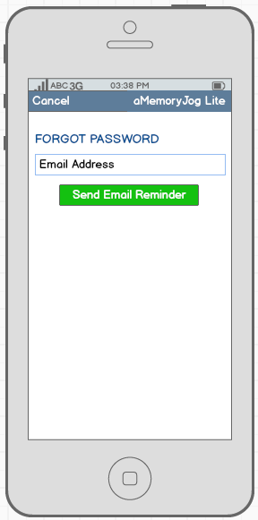
Colors:
Top Navigation Bar background: Blue (#5e7d9a)
Top Navigation Bar foreground: White
Page background: White
Labels (e.g. FORGOT PASSWORD label: Blue (#085394)
Text Boxes: White with blue (#5e7d9a) border
Send Email Reminder Button: Green (#14c110), White text
Cancel button in Nav Bar:
Text: Cancel (pull from Localizations.English field by querying based on ItemType=‘General’, ItemName=‘btnCancel’)
Cancel Navigates the user back to the Login page.
FORGOT PASSWORD label:
Text: FORGOT PASSWORD (pull from Localizations.English field by querying based on ItemType=‘frmForgotPassword’, ItemName=‘lblTitle’)
Email Address:
Placeholder Text: Email Address (pull from Localizations.English field by querying based on ItemType=‘frmForgotPassword’, ItemName=‘lblEmail’)
If the user never logged in before, it will display the placeholder text. If the user has logged in before, it will display the email they last logged in with.
Send Email Reminder Button:
Text: Login (pull from Localizations.English field by querying based on ItemType=‘frmForgotPassword’, ItemName=‘btnSendEmailReminder’)
When Send Email Reminder button touched, it will determine if the Email was entered. If not, it will display this error message from Localizations.English field by querying on ItemType=‘Messages’, ItemName=‘MISSING_EMAIL’.
If Email entered, it will determine if the Email Address matches (not case sensitive) an entry in the database. If not, it will display an error message from the Localizations.English field by querying on ItemType=‘Messages’, ItemName=‘INVALID_EMAIL’. One of the words in the Localizations.English field will be [PRODUCTNAME], replace that with aMemoryJog.
If Email matches, it will send an email to the email address entered:
SEND TO: [Email Address]
SUBJECT: aMemoryJog iPhone App - Forgot password
BODY: So you forgot your password to the AMemoryJog iPhone app? No worries. To login, enter this email address: [Email Address] and this password: [Password].
Note: Replace [Email Address] with email entered and [Password] from Users.UserPassword.
Once the email is sent, display an Alert message that tells the user that their password was emailed to them. Get the message from the Localizations.English field by querying on ItemType=‘Messages’, ItemName=‘SENT_PASSWORD_REMINDER’. Once they accept the alert, it should automatically navigate back to the Login screen.

Section 1.1.3 Create New Account Screen
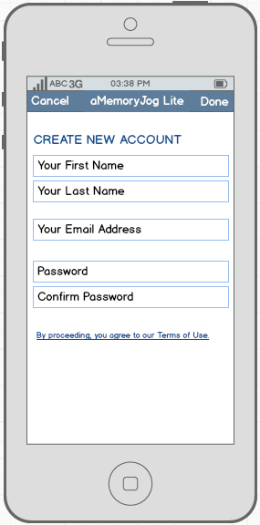
Colors:
Top Navigation Bar background: Blue (#5e7d9a)
Top Navigation Bar foreground: White
Page background: White
Labels (e.g. Create New Account) label: Blue (#085394)
Text Boxes: White with blue (#5e7d9a) border
Link (By Proceeding…): Blue (#2b78e4) and underlined
Cancel button in Nav Bar:
Text: Cancel (pull from Localizations.English field by querying based on ItemType=‘General’, ItemName=‘btnCancel’)
Cancel navigates the user back to the Login page.
Create New Account label:
Text: CREATE NEW ACCOUNT (pull from Localizations.English field by querying based on ItemType=‘frmCreateNewAccount’, ItemName=‘lblTitle’)
Your First Name:
Placeholder Text: Your First Name (pull from Localizations.English field by querying based on ItemType=‘frmCreateNewAccount’, ItemName=‘lblFirstName’)
Your Last Name:
Placeholder Text: Your Last Name (pull from Localizations.English field by querying based on ItemType=‘frmCreateNewAccount’, ItemName=‘lblLastName’)
Your Email Address:
Placeholder Text: Your Email Address (pull from Localizations.English field by querying based on ItemType=‘frmCreateNewAccount’, ItemName=‘lblEmail’)
Password:
Placeholder Text: Password (pull from Localizations.English field by querying based on ItemType=‘frmCreateNewAccount’, ItemName=‘lblPassword’)
Confirm Password:
Placeholder Text: ConfirmPassword (pull from Localizations.English field by querying based on ItemType=‘frmCreateNewAccount’, ItemName=‘lblPasswordConfirm’)
Done button in Nav Bar:
Text: Done (pull from Localizations.English field by querying based on ItemType=‘General’, ItemName=‘btnDone’)
When Done is pressed, it will perform these edits:
- All fields require data to be entered in them. If any do not have data, display an error message (pull from Localizations.English field by querying based on ItemType=‘Messages’, ItemName=‘MISSING_FIELDVALUE’.).
Example:
No [FieldName] entered, please re-try. (Replace [FieldName] with the localized field name)
e.g. No Your First Name entered, please re-try.
- If all fields contain data, check the password to ensure it contains at least 6 characters of data. If not, display an error message (pull from Localizations.English field by querying based on ItemType=‘Messages’, ItemName=‘INVALID_PASSWORDTOOSHORT’.).
Example:
Your new password must be at least [minPasswordLength] characters, you entered only [actualPasswordLength] characters, please re-try. (Replace [minPasswordLength] with 6 and [actualPasswordLength with the number of characters they entered)
e.g. Your new password must be at least 6 characters, you entered only 3 characters, please re-try.
- If all fields contain data and password is at least 6 characters, compare the Password with the Confirm Password for a case-sensitive match. If they do not match, display an error message (pull from Localizations.English field by querying based on ItemType=‘Messages’, ItemName=‘INVALID_NEWPASSWORD’.).
Example:
Your new password and confirm password must match, please re-try.
- Determine if the Email contains an ampersand (@) and a period (.). If not, display an error message (pull from Localizations.English field by querying based on ItemType=‘Messages’, ItemName=‘INVALID_EMAILFORMAT’.).
Example:
The email entered is invalid, an email must contain an ampersand and a period.
- If no other errors, check Users.Email to see if the email entered already exists in the database. If it does, display an error message (pull from Localizations.English field by querying based on ItemType=‘Messages’, ItemName=‘DUPLICATE_EMAIL’.).
Example:
The email entered is already setup to use AMemoryJog. To login with this email, navigate to the Login page and enter this email and your password. If you forgot your password, click Forgot Password from the Login page.
Once all the edits above pass validation, it will setup the User account:
- Writes to the Users table from the fields entered on the screen (Email, FirstName, LastName, Password). All other fields will be set to their default values). A unique UserId is automatically generated upon saving the data.
- Writes to the Devices table (UserId comes from the Users.UserId that was just saved), a unique DeviceId is automatically generated and all other fields will be set to their default values).
- Once Users and Devices tables written, it will automatically navigate to the Item Listing screen.

Section 1.2 Item Screens
Once a user has logged in, the main set of screens used to track items is displayed (items hold account numbers, passwords, frequent flyer, loyalty programs, etc.).

Section 1.2.1 Home Screen (Item Listing)
[Hidden from Sample for brevity]

Section 1.2.2 Item Detail Read-Only Screen
[Hidden from Sample for brevity]

Section 1.2.3 Item Maintenance Screen
[Hidden from Sample for brevity]

Section 1.3 Settings Screen
[Hidden from Sample for brevity]

Section 1.4 Help Screen
[Hidden from Sample for brevity]

Section 2: aMemoryJog Pro
aMemoryJog Pro will be the paid edition of the password management tool that offers these additional benefits over the Lite edition:
- No nag screen for upgrading from Lite to Pro
- No banner ads at the bottom of the page
- The ability to back up the data to the cloud (our web server). The backup service also comes with a free web based edition of the software as part of the service.
- The ability to restore deleted records.
- The user can choose one of the languages for Localizations: English, Spanish, German, Italian, French, Russian, Japanese, or Chinese.
For maximum re-usability, the same logic will be used for the Lite and Pro editions, with conditional statements for any differences in logic.

Section 2.1 Login Screens
When a user downloads and opens up the app, the first screen they encounter is the Login screen.

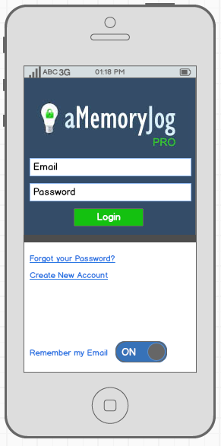
Section 2.1.1 Login Screen
Here are screen captures of Pro and Lite. The differences between the two:
- aMemoryJog Logo - One says LITE the other says PRO
- Localizations – All text on screen is pulled from Localizations. With Lite, the data is queried from the Localizations.English field. With Pro, the data is queried from Localizations.[Language] field, where [Language] is the Language chosen in the Section 2.3 Settings screen.
- Devices – AMemoryJogLite and AMemoryJogPro has different Devices records (DeviceName = ‘AMemoryJogLite’ or DeviceName = ‘AMemoryJogPro’)

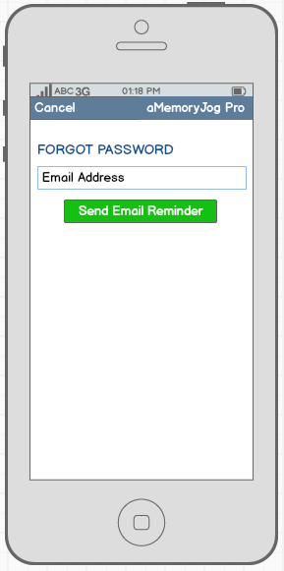
Section 2.1.2 Forgot Password Screen
Here are screen captures of Pro and Lite. The differences between the two:
- Top Nav Bar - One says AMemoryJog Pro, the other says AMemoryJog Lite.
- Localizations – All text on screen is pulled from Localizations. With Lite, the data is queried from the Localizations.English field. With Pro, the data is queried from Localizations.[Language] field, where [Language] is the Language chosen in the Section 2.3 Settings screen.

Section 2.1.3 Create New Account Screen
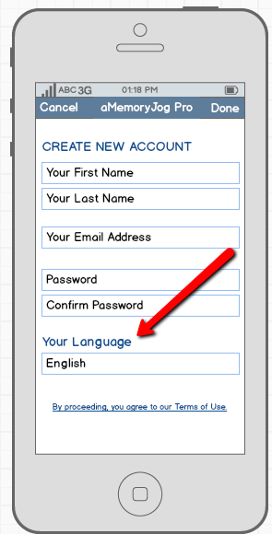
Here are screen captures of Pro and Lite. The differences between the two:
- Top Nav Bar - One says AMemoryJog Pro, the other says AMemoryJog Lite.
- Localizations – All text on screen is pulled from Localizations. With Lite, the data is queried from the Localizations.English field. With Pro, the data is queried from Localizations.[Language] field, where [Language] is the Language chosen in the Section 2.3 Settings screen.
- Devices – AMemoryJogLite and AMemoryJogPro has different Devices records (DeviceName = ‘AMemoryJogLite’ or DeviceName = ‘AMemoryJogPro’)
- Your Language – The Pro edition will have a label called Your Language where the user can choose the language they wish the information to be shown in. The wording for the Your Language label is pulled from Localizations (ItemType= ‘frmCreateNewAccount’, ItemName=’ lblLanguage’). If the device’s local language has been set to English, Spanish, Italian, German, French, Russian, Japanese or Chinese, it will default to that when they come into this screen and all information on the screen will be shown in that language, otherwise, it will default to English. The language field changed via a picker with list of choices being: English, English (Funny), Spanish, Italian, German, French, Russian, Japanese or Chinese. The chosen language is stored in Users.UserLanguage.

Section 2.2 Item Screens
Once a user has logged in, the main set of screens used to track items is displayed (items hold account numbers, passwords, frequent flyer, loyalty programs, etc.).

Section 2.2.1 Home Screen (Item Listing)
[Hidden from Sample for brevity]

Section 2.2.2 Item Detail Read-Only Screen
[Hidden from Sample for brevity]

Section 2.2.3 Item Maintenance Screen
[Hidden from Sample for brevity]

Section 2.3 Settings Screen
[Hidden from Sample for brevity]

Section 2.4 Help Screen
[Hidden from Sample for brevity]

Section 2.5 Recycle Bin Screen
[Hidden from Sample for brevity]

Section 2.6 Sync Screen
[Hidden from Sample for brevity]

Section 3 – Nag Alerts
We will have a few nag alerts that are used to encourage the user to upgrade to paying services or write a review.

Section 3.1 Upgrade from Lite to Pro Nag Alert
[Hidden from Sample for brevity]

Section 3.2 Renew Cloud Backup Alert
[Hidden from Sample for brevity]

Section 3.3 Ask for Review
[Hidden from Sample for brevity]

Section 4 – Cloud Synchronization
[Hidden from Sample for brevity]

Cloud Database (Web Server)
[Hidden from Sample for brevity]

Cloud Database Account Creation and Authentication
[Hidden from Sample for brevity]

Sync Localizations Updates from Cloud to Mobile
[Hidden from Sample for brevity]

Sync Cloud and Mobile Data
[Hidden from Sample for brevity]

Section 5 – Icons and Screen Shots for App Store
We will need icons for both aMemoryJog Lite and aMemoryJog Pro to be used in the App Store. You might consider creating an icon that is similar to our current aMemoryJog icon for the web version:
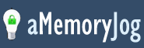
But you might consider using just the light bulb.
Additionally, we will need screenshots for AMemoryJog Lite and Pro for the App Store. We will need both regular sizes as well as 2x sizes. All icons and screen shots should be created in a vector based format so that scaling will look good. We will need 5 screenshots for Lite and 5 screenshots for Pro.
For aMemoryJog Lite, they will probably be:
- Home Page (Item Listing)
- Item Detail Read-Only Screen
- Item Maintenance Screen
- Settings Screen
- Help Screen
For aMemoryJog Pro, they will probably be:
- Home Page (Item Listing)
- Item Detail Read-Only Screen
- Settings Screen
- Recycle Bin Screen
- Sync Screen
We will also need a splash screen to look like this; it will look similar to the login page without the data entry fields or links.

Section 6 – Flurry Analytics
Flurry Analytics (http://www.flurry.com/flurry-analytics.html) works similar to Google Analytics, but is designed for mobile apps. It allows us to track demographics and specific app usage for each of our apps. Their website says that it can be implemented in about 5 minutes. We would like this implemented so that we can track what countries are using the app, churn rate, age and other demographics, the languages spoken by people using our apps, which buttons are clicked in our app, along with how clients are using our apps.

Section 7 – Error Trapping
The app should use standard practices for handling errors. If an unexpected error occurs, we would like a specific error message to be displayed. You can pull this error message from Localizations, ItemType=’Messages’, ItemName=’GENERAL_ERROR’.
Also, if the user tries to use any feature that calls out to the web or needs to be online, it will display a message telling them that they need to be online to use the feature (Localizations, ItemType=’Messages’, ItemName=’OFFLINE’).

