aMemoryJog: Web Password Manager
A web application that remembers passwords and other private information
‘aMemoryJog’ version 1.1 is now available for download
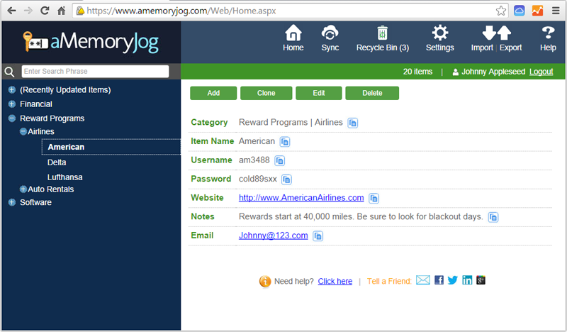
PANAMA CITY BEACH, FL – October 15, 2014 – Available today, version 1.1 of the aMemoryJog password manager for the web is available for download. aMemoryJog offers the ability for users to securely store passwords and other private information (accounts, credit cards, frequent flyer information, loyalty cards and more). Information is backed up to the cloud and secured with 256-bit encryption.
Version 1.1 includes a Recycle Bin for restoring deleted records, enhanced import capabilities, and multi-lingual support for 8 languages. aMemoryJog web edition is available for $9.99 per year and offers a free 30 day trial. Please visit http://www.aMemoryJog.com for more detailed information, screen shots, and videos. aMemoryJog works from a PC, Mac, tablet, or any other web-enabled mobile device.
aMemoryJog is developed by Flip Flop Software, a mobile development company founded in 2013.
###
For further information on aMemoryJog or to schedule an interview, please contact:
Steve Miller, Marketing and Communications, Flip Flop Software
Phone: (+1) 303-587-7389 Email: steve@flipflopsoftware.com Twitter: @aMemoryJog

